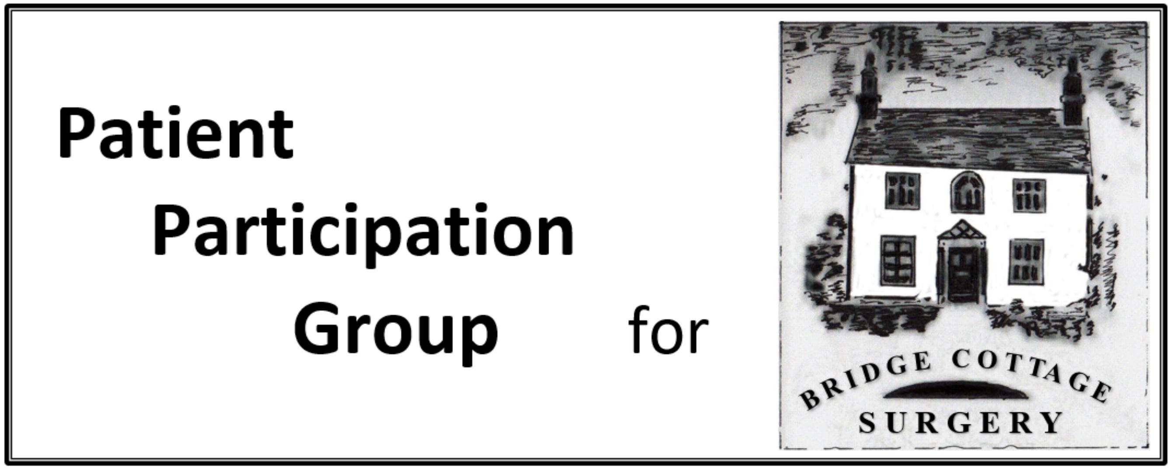

|  |  |  |
| --- | --- | --- |
| **PPG Minutes** | | |
| **Meeting Date** | 18th November 2019 | |
| **Present** | I Skidmore, S Otty, A Gillman-Smith, J Jacklin, P Bridge, L Boon, D Bell, R Aubrey, J Young, D Crossley, D. Shearley (welcomed as an observer), G. Lamb, J. Green, R. Walker  Dr Saiyeesh Maheswaran in attendance for the first part of the meeting answering questions relating to the Practice Managers meeting notes | |
| **Apologies** | L. Watson. | |
| **Agenda Item** | **Notes** | **Action** |
| **Minutes** | Minutes of the meeting of 30th September 2019 were approved. |  |
| **Practice Managers Meeting** | Notes from the meeting had been circulated highlighting some areas where the practice felt that the PPG could assist.  Two items were discussed in more detail – pneumococcal injections for the over 65’s. It was agreed that this would be highlighted at the PPG table. Recall criteria to be reviewed for invite letters.  Long Term conditions review – again invitation letters are sent to those meeting criteria – in particular COPD, Cardiovascular ailments. To be subject of a magazine article and also feature on the PPG table.  Patients to be directed to the NHS Health Care website for reliable information (rather than random internet searches).  Frailty Checks – uptake for these has been low. Ian to discuss with other PPG’s how they address this. It was clarified that these are 30 minute appointments normally carried out by the specialist nursing team. These can be difficult discussions as they cover long term planning for end of life etc. It was reported that the surgery covers a number of care homes, and patients are approached by that method. There was concern raised about the repetitive nature of long term planning reviews as the same questions are often asked by different agencies. It was agreed that this was a pan NHS problem rather than practice specific and Ian would raise the issue at a CCG meeting. | DC  DC  IS  IS |
| **Matters Arising** | There were none |  |
| **Primary Care Networks – General update** | We/the practice will not have any firm information about how this will be taken forward until at least January, but in the meantime, the status quo will remain until April. |  |
| **Primary Care** **Networks** | The new Clinical Director is Dr. Gilham from Peartree Surgery.  The Clinical Pharmacist is now in place at Bridge Cottage and Peartree are looking into this.  IS and SO have met with representatives from Peartree to share information/best practice. We have invited one of their members to attend a meeting as an observer and have been invited to their next meeting for the same purpose. This will be in January. | DC. |
| **Long term Conditions Strategy** | RW attended the meeting on 23rd October.  Strategy will concentrate on Shared Decision Making, self management, life style changes, social prescribing and the Dr/Patient relationship. The full report should be issued early next year. There will have to be prioritisation for this to be successful. | RW/IS |
| **Cancel Out Cancer** | Ian put forward a proposal that this should be treated as a Community initiative and he proposed that he contact the Parish Council who should be able to provide a venue and help with communication of the event. This should also include Kimpton, Codicote and Digswell. Pat Bridge and Deborah Shearley volunteered to help with contacts at Kimpton and Codicote Parish Councils. |  |
| **Communications:**  **Thursday Table**      **Magazine** | Next Table – 28th November – David and Ann have volunteered already. IS to check stocks of leaflets and advise Debbie. Leaflets to be included were pneumococcal and shingles. Pat and new members/those who hadn’t done it before invited to attend as observers. Should also include info on the Urgent Care Centre??.    December 12th – Ian and Sara to man the table. Include info on Sepsis and Stroke.  January 23rd – next table – volunteers asked for  January will feature: Clinical nurse, physiotherapy and pharmacist.  February – Dementia  March – Long Term Conditions Reviews.  Communication remains a critical challenge and we need to look at using local newsletters and parish notice boards (for example) – Pat and Deborah offered to facilitate leaflets in outlying districts – notice boards/pharmacies etc. Sara to send them magazine articles once finalised. | IS  SO |
| **AOB** | Practice Leaflet. A draft had been circulated and PPG members invited to make comments. A number were discussed at the meeting, and it was decided that each PPG member should email Debbie with their suggestions.  Practice Survey – Debbie reported that the practice had reached it’s target and were now expecting the feedback.  E-Consultations – Dr. Chandarana would be attending a seminar on this subject and he would report back. | ALL |
| **Date of next meeting** | 12th January 2020 |  |
| **Date of Annual General Meeting** | 10th February 2020 at 7pm at Bridge Cottage Surgery |  |