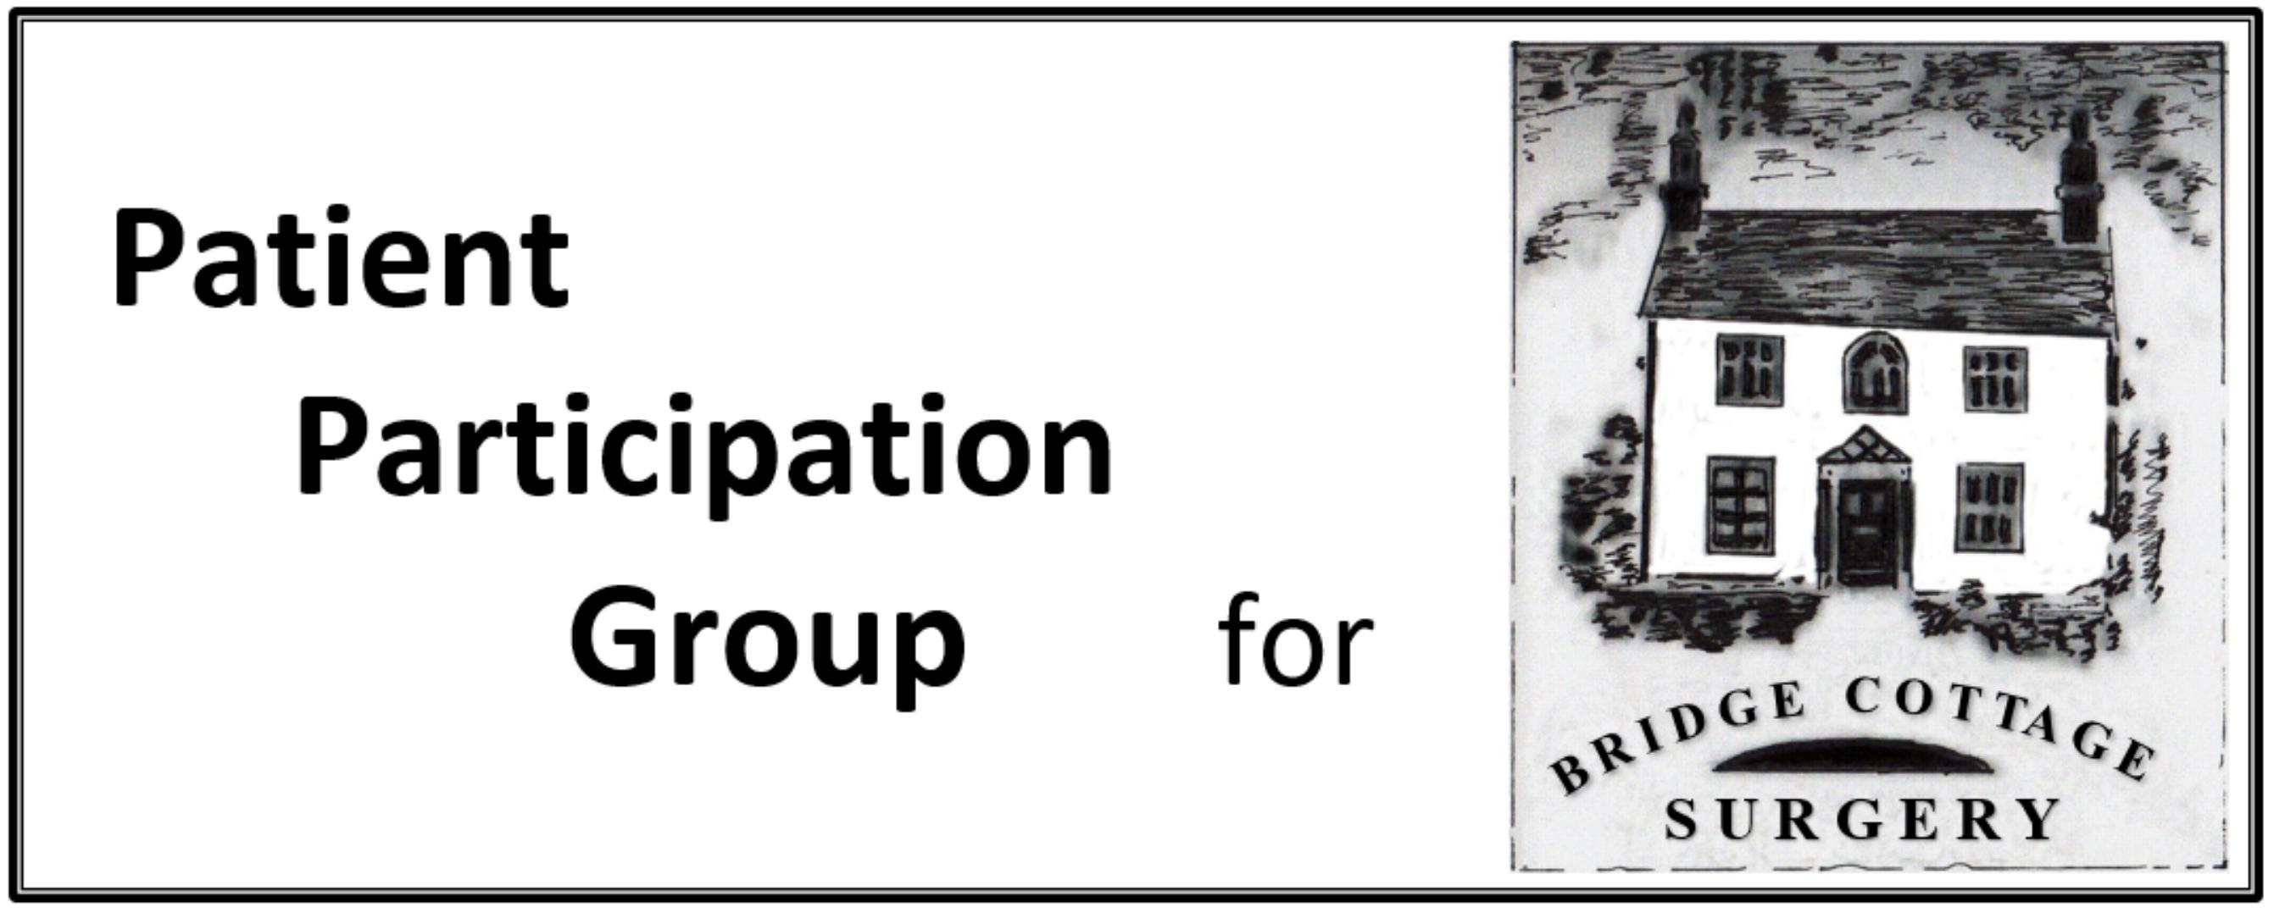

|  |  |  |
| --- | --- | --- |
| **PPG Minutes** | | |
| **Meeting Date** | Monday July 16th | |
| **Present** | J Green, S Otty, D Crossley, R Walker R Aubrey, A Nation, I Skidmore, G Lamb, D Bell, C Anning,  C Bailey, A Gillman Smith, J Gillman Smith | |
| **Apologies** | L Boon, J Jacklin H jiggens L Watson | |
| **Agenda Item** | **Notes** | **Action** |
| **Presentation** | A presentation on abdominal aortic aneurysm was given. Men over the age of 65 are most at risk and get letters from NHS inviting them to have a scan at a local GP surgery, closest ones are Hatfield and Stevenage Old Town. A survey at the Street market suggests that about half of those asked had been scanned. Older men (70+) will not have been invited and so efforts to identify them will be of value. |  |
| **Minutes** | The Minutes of the meeting of May14th were approved. |  |
| **Matters arising** | The minutes are now being published on the Practice website.  DC will circulate the final version of the report on the PPG to the CCG  IS, having joined Healthwatch Hertfordshire has heard nothing yet and will follow up.  The CCG public engagement strategy has been finalised and circulated to the PPG for discussion at the next meeting. (See below) |  |
| **Flu vaccination** | There is a new triple vaccine (FLUAD) for over 65’s. Supplies will be delivered in September, October and November so vaccination will be staggered accordingly. The children’s quadrivalent vaccine remains the same.  PPG members will take advantage of the sessions to provide leaflets (Shingles and AAA?) |  |
| **NAPP conference** | AG-S reported on this. About 100 delegates were present and useful presentations were given. There were several workshops. (PPG/practice managers interaction)  Video recordings of the presentations are on the NAPP website as are recordings of the “soapbox sessions”.  There was a presentation from an officer of the GMC on re-evaluation of GPs.  A key message of the conference was improving the continuity of care, in particular on hospital discharge. |  |
| S**treet market** | There was a lower take up on the quiz this year, IS has circulated analysis plus some suggestions for next year. This will be an agenda item for the September meeting. Leafleting for AAA was very useful. |  |
| **Cancer statistics** | JG reported that NHS England are keen to improve the performance of the UK as compared with other European countries in term of earlier identification, quicker assessment and improved outcomes.  GOP surgeries will be required to appoint a cancer Champion to promote screening and greater awareness of symptoms. A meeting of local champions will be held shortly. |  |
| **Phlebotomy questionnaire** | It appears that the CCG wishes to reorganise the phlebotomy service, possibly making it more centralised? PPG had been provided with a link to a simple questionnaire on this. |  |
| **Engagement Strategy** | As noted above this has been circulated to PPG members. Comment was that translating strategy into action is the main challenge and if the PPGs are going to be involved (via PCG?) then good communication will be needed from and to CCG. JG noted that it emphasised the need to knit health and social care, a national issue, as apart of a wider dimension of continuity of care. |  |
| **New members** | 4 potential new members introduced themselves, GL, DB, CB and CA; two other potential members could not be present. |  |
| **Date of next meeting** | Monday 10th September, 10am |  |
|  | | |