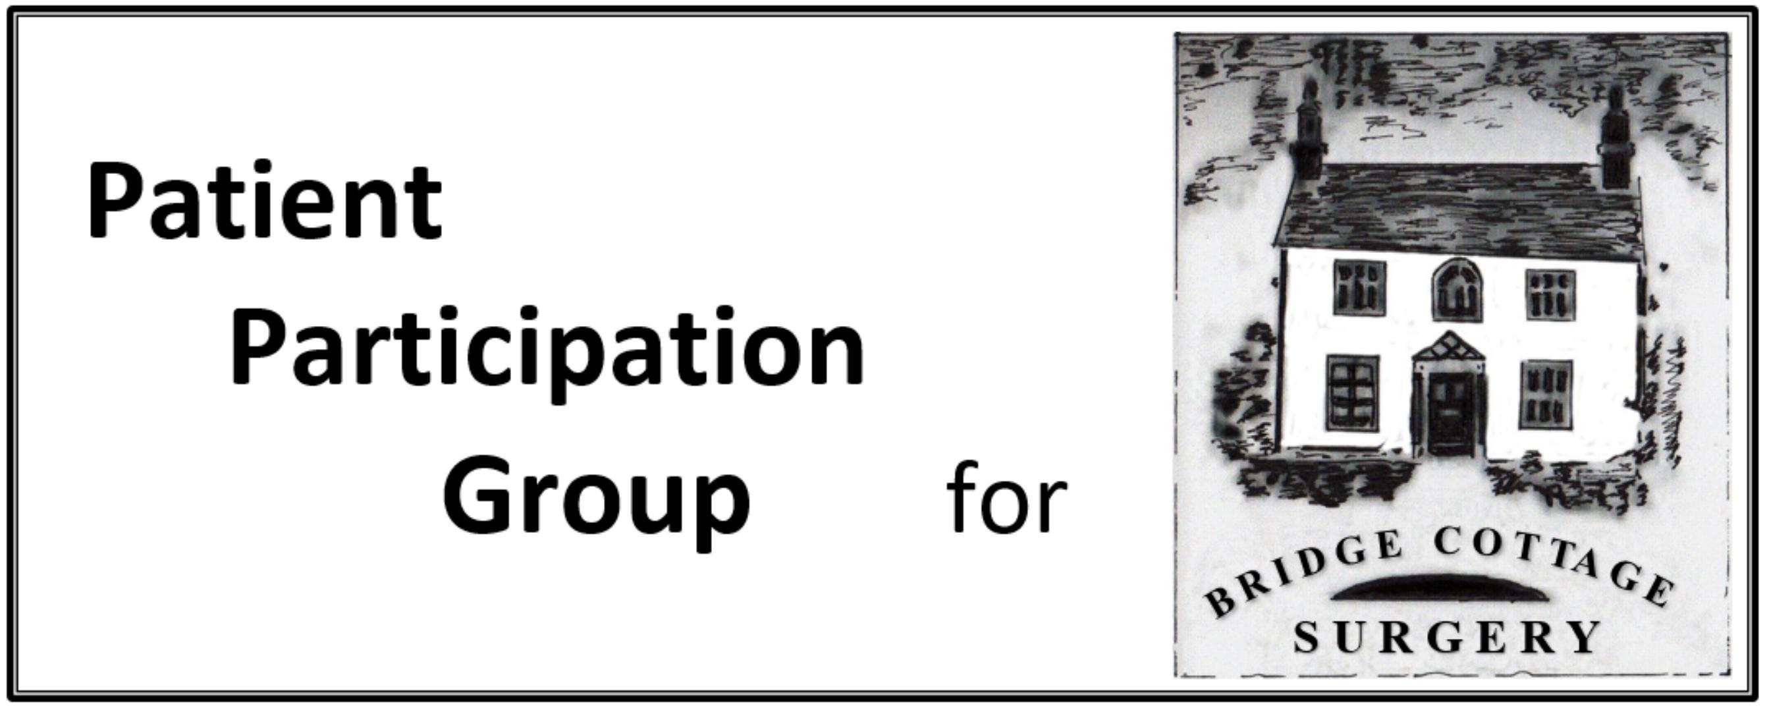

|  |  |  |
| --- | --- | --- |
| **PPG Minutes** | | |
| **Meeting Date** | 19th November 2018 | |
| **Present** | J Green, S Otty, L Boon, A Gillman-Smith, J Jacklin, R Aubrey, A Nation, R Walker, I Skidmore, L Watson , D Crossley, D Watkiss (now deputy Practice Manager) | |
| **Apologies** | G Lamb. D Bell | |
| **Agenda Item** | **Notes** | **Action** |
| **Minutes** | Minutes of the meeting of 12th September 2018 were approved |  |
| **Matters Arising** | Performance Audit: SO, RA and JJ will carry this out before the AGM.  Flu Vaccinations; Supplies have all been used.  Shingles Vaccine: Current supplies exhausted but more may be available. The PPG leafleted the Flu vaccination sessions to raise awareness. | SO, RA, JJ |
| **Communication methods** | SO and JG had been to a Patient Locality Network (PLN) meeting where experiences of communication methods were discussed. No-one has an ideal solution. Facebook was not favoured for general communication. Potterells have sent out links to a You Tube video on Social Prescribing. Garden City have used a Newsletter.  We discussed the Newsletter and were concerned that they may contain too much information and that really important information less frequently would be more valuable. Debbie will aim to refresh the website. Knebworth have an information table in the surgery for a whole morning once a month and we agreed that this could be a good way of getting information, questions and answers in both directions. We will set this up using the area at the far end of the downstairs waiting room. We will need to establish a process and a rota for this.  Knebworth have a Whole Practice meeting once a year (instead of AGM?) where key topics are presented/discussed.  Concern was expressed that some groups, for example teenagers, new undergraduates, fall through the communication net. It was acknowledged that this is a difficult area. Parental influence may be at a minimum! | DC  All |
| **Social Prescribing** | The Herts Help leaflet had been circulated and we will be placing copies in the Community Café, The Surgery and the Library.  CCG informs us that there is also a Hospital and Community Navigation Service that is being extended throughout ENH and Herts Valleys CCGs, funded by both of them and HCC. Some Practices have become involved in this, setting up Community Navigation Clinics.  Further discussion is needed.  POwHER is another community service, local base in Stevenage. |  |
| **Stroke Leaflets** | We have some of these and an information pack. Stroke is currently running on the Screens. We need to work out how to get information out more widely (see info table comment above.). |  |
| **Medicines waste** | The cost of medicines prescribed but unused in Herts and West Essex is £7M pa. There is currently a campaign encouraging patients to check that not only do they have the right medicines but that unwanted ones are not carried out of the pharmacy.  Medicines waste and unnecessary stockpiling by patients is also what underpins the unwillingness of NHS England to move away from monthly repeat prescriptions for chronic medication despite concerns about shortages of critical medication post 29th March 2019. |  |
| **OTC Medicines** | The policy on OTC medicines is now in place |  |
| **Magazine Articles:** | The February Article will be on Cervical Cancer, January is Cervical Cancer Awareness Month. Three slides have been produced (question as to whether vaccination should be more prominent in these).  Post meeting note: From next year vaccination will be available for boys, to enhance “herd immunity” . |  |
| **Frequency of Meetings** | We still need to finalise this, perhaps at AGM. |  |
| **AGM** | Date is 25th February 2019 Bridge Cottage 7pm/ JG has indicated very clearly that he will be standing down as Chair so we need a replacement. Those interested should contact IS. | All |
| **Date of next** **meeting:** | 25th January 10.am Bridge Cottage | All |
| **AOB** | Flash Glucose Monitoring: This is available via Diabetes Clinics for those who qualify by nature of their condition (despite reports of postcode lottery this is now throughout England)  Members are encouraged to complete the Survey noted in the “three things” email.  A G-S reported to JG that the Chair of NAPP has resigned and the future is somewhat uncertain at present  JG, AG-S and AN will be going to the CCG celebration on 12th December. | All |
|  | | |
|  | | |